# Background of the Eduroam Project

In the global research environment, researchers often travel to other institutions for conventions and research collaborations. One of the essential services these researchers need in their work is Internet access. One solution is to subscribe to the roaming data plans provided by the telecom operators. However this option is expensive and unnecessary since most research institutions provide wireless Internet access. The only remaining problem lies in whether the visiting researchers have the permission to access these networks.

Eduroam is an international secure roaming service implemented for the research and education communities to address the issue of providing seamless internet access to visiting academics and research fellows to the institution. It is currently implemented in 74 countries from North and South America, Europe and Asia. Eduroam provides users from participating institutes seamless and secure Wi-Fi access to the Internet at other participating institutions around the world. 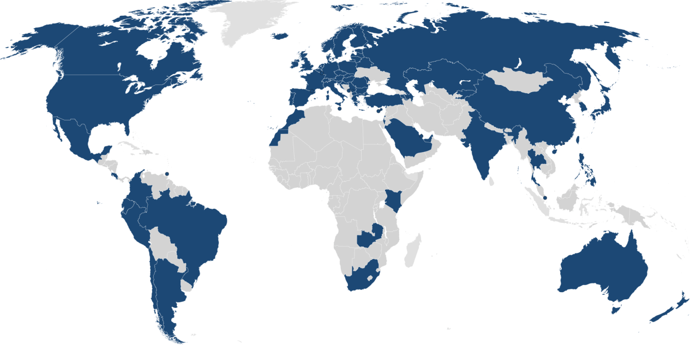

Figure Map of eduroam coverage

Eduroam utilises a hierarchical RADIUS server infrastructure and the IEEE 802.1x standard networking protocol to provide roaming Internet service across research and education networks across the world. (1) The RADIUS server hierarchy is involved in forwarding user credentials to the home institution of the user for validation and verification purposes. The IEEE 802.1x technology standard defines the end-to-end encryption and authentication protocol over the wireless connection offered by Eduroam.

Authentication and authorisation of access is performed under the following arrangement, where users are authenticated at their home institutions which act as Identity Providers (IdPs) and the authorisation for user network access is handled by the host institution providing the access points as a Service Provider(SP). When the user first requests authentication at a SP, the SP looks for the realm of the user that indicates the IdP associated with the user. The realm can be found in the form of userid@IdP.TLD, where IdP refers to the domain name of the home institution and TLD indicates the top-level domain in which the institution belongs to. For instance, the National University of Singapore (NUS) belongs to the top-level .sg domain. Each institution has its own RADIUS server connected to a local user database. With the information from the user realm, the RADIUS server can route that request to the following suitable RADIUS server until the correct Identity Provider is reached. At the Identity Provider, the user authentication details can be validated with the user data in the local database and transport the validation result back to the SP. User access authorisation is then conducted by the SP and network access is granted to the user by allocating a specific VLAN for visitors.

The secure transmission of user authentication details across the RADIUS server infrastructure is maintained by the IEEE 802.1x standard, which utilises the Extensible Authentication Protocol (EAP). The function of EAP is to encapsulate the authentication data such that only the user and its IDP are aware of the actual authentication process, and other users will be unable to hijack the connection after successful verification. WPA2-Enterprise, a security mechanism for wireless networks, is used for encrypting the authentication data to prevent eavesdropping for the user credentials.

# Organisation of Eduroam Infrastructure

The following diagram is an illustration of the hierarchical RADIUS server infrastructure adopted by Eduroam. It is divided into 3 levels, namely the Confederation level(ETLRs), the Federation level(FLRs) and lastly, the Institutional level(IdPs and SPs). (2)

Figure Hierarchy of Eduroam servers

The confederation top-level RADIUS (TLR) servers are authoritative top-level domains coordinating the operation of eduroam servers within the regions under their jurisdiction. Each TLR has a list of connected country domains serving the appropriate National Research and Education Networks(NRENs). The TLRs accept requests for federation domains under their authority and then forward them to the respective federation RADIUS server. Requests for domains not under their authority would be forwarded to the proper confederation server. Currently, there are two confederation-level TLRs based in Europe known as ETLRs that handle requests from the European NRENs and also NRENs from other parts of the world.

The federation-level RADIUS (FLR) servers are responsible for handling requests between the IDPs/SPs and the upstream confederation TLRs. Each FLR possess a list of connected IdPs and SPs, and they redirect requests to the proper SP based on the user realm. Requests with destinations not under their authority would be forwarded upstream to the TLR. The FLR is operated by the NREN of the territory to manage connections from its member institutes. For instance, the FLR for Singapore is maintained by SingAren. (3)

The bottom-level servers consist of IdPs and SPs participating in eduroam. They are responsible for the actual authentication of their own users through the validation of the user’s credentials with their internal database. They are also tasked with forwarding access requests from visiting users to the associated federation server.

The hierarchical structure of RADIUS servers hence ensures that the transport of user authentication details can be conducted effectively between the SPs and the IdPs across different federations of networks.

# Eduroam Statistics Project

The Eduroam statistics project was set up by the SingAren staff in 2013 as an effort to allow member institutes to track their eduroam usage statistics and detect any problems that may arise in the operation of the Eduroam system. Currently, the Eduroam statistics project consists of a conversion program running on the eduroam server and a rudimentary graphing of the usage statistics for each institution. The Eduroam statistics system was currently operated manually by the SingAren staff.

# Bibliography

1. **GEANT Association.** eduroam in a nutshell. [Online] August 12, 2014. https://wiki.geant.org/display/H2eduroam/eduroam+in+a+nutshell.

2. **M. Milinović, Srce / CARNet, Stefan Winter, RESTENA and members of the SA3 T2 group.** eduroam Policy Service Definition. [Online] July 26, 2012. https://www.eduroam.org/downloads/docs/GN3-12-192_eduroam-policy-service-definition_ver28_26072012.pdf.

3. **Singapore Advanced Research & Education Networks.** eduroam Project - Welcome to eduroam in Singapore. *SingAren Web Site.* [Online] July 31, 2014. http://www.singaren.net.sg/Eduroam.php.